Abstract:
Abstract (should be provided for papers and letters only) should be no longer than 200 words. This file is a template to be used for submitting papers to the Journal of the Marine Acoustics Society of Japan (MASJ). Use of Microsoft Word is a pre-requisite. If other software is used to create the file, it should be submitted in a format similar to the one shown in this file. The contents of this paper are excerpted from and adapted from the Author Guidelines for the Journal of the MASJ, and are intended as a reference example for authors to present their manuscripts in a proper format that will facilitate efficient work during peer review and other processes. Manuscripts should be prepared in accordance with the Author Guidelines. Please note that the Author Guidelines listed as a sample of the text may have been revised, so be sure to check for the latest version posted on the website of the MASJ.
0. Manuscript Format
This file is a template file designed for manuscripts of papers and letters. It is recommended that manuscripts of other categories be prepared according to this format. Manuscripts should be prepared in accordance with the Author Guidelines for the Journal of the MASJ¹⁾.
The standard paper size is A4 and the standard font is Times New Roman. Font size should be 12 pt. and about 25 lines per page. The standard margins are 30 mm at the top, left and right, and 35 mm at the bottom. The line number should be inserted at the right hand corner of the line with the serial number and starting from the first page, and the page number, the name of the primary author, and the title should be written in the footer. If the title is too long to fit on one line, stop at the appropriate place and end with "...".
(For peer review) A manuscript should be arranged in the following order: abstract, page break, main text, page break, list of references, page break, figures, photographs, and tables. The pages should be numbered from the first page through to the figures. Manuscripts should be submitted electronically as a single PDF file. In addition to the manuscript file, fill out the cover page for submission. The cover page for submission can be obtained from the website of the MASJ.
The following chapters are the Author Guidlines for the Journal of the MASJ (revised in April, 2024). The Author Guidlines may have been revised. Be sure to check the latest version posted on the website of the MASJ.

- General Guidelines
  - Manuscripts must be original articles written by the author(s), and must not have been made available (distributed or sold) to the public.
  - The Marine Acoustics Society of Japan (MASJ) publishes the Journal of the MASJ four times each year (January, April, July, and October). Papers and letters are also published in J-STAGE―the electronic version of the Journal―three months after publication in the Journal.
  - The first author must be a member / honorary member / life member / supporting member of the MASJ. It is preferable for coauthors also to be MASJ members. When students submit a paper, at least one of the coauthors should be a member of the MASJ. However, this rule does not apply to authors invited by the Editorial Committee of the MASJ.
  - Manuscripts should be prepared in Japanese or English. Each submitted manuscript should be accompanied by a cover page and an English abstract (papers and letters only), and include the main body, along with any supporting figures, photographs, and tables.
  - As a general rule, manuscripts should be created using word processing software.
  - The number of manuscript pages should generally not exceed the number specified in Table 1 (including figures, photographs, and tables).
  - Manuscripts should conform to one of the three types listed in Table 1. Download the cover page from the website of the MASJ, and register the type on the cover page.
  - A standard printed page comprises 850 words (average of five alphabetical characters per word).
  - The author has ultimate responsibility for the published content.

- Copyrights
  - The papers published in the Society’s journal are treated pursuant to the copyright rules of the Society. In addition, they will be similarly treated even if the author is not specified.
  - If drawings, photographs, charts or the like in other publications or literature will be cited in the papers to be contributed, their origins shall always be specified and be cited to the reasonable scope set forth in the Copyright Act. In addition, if such citation will exceed the rea- sonable scope, the permission to use set forth by the copyright holder of the corresponding publication or literature must be obtained.

- Title
The title should be as simple as possible. The first letter of the words in the title should be capitalized except for articles, prepositions, and conjunctions.

Example: Statistical Properties of Processing Gain from Lofargram Smoothing Using Morphological Filters.

- Name and Affiliation
  - Include the author’s (contributor’s) name on the cover page.
  - Affiliation refers to the name of the affiliated institution or company for whom the author is working. It is written by the institution or company name and one appropriate department or division name. The description of legal personality is optional.
  - Each paper or letter article requires the name and email address of a corresponding author (for contact purposes). The corresponding author need not be the first author, but is simply the one to be contacted by us if needed.

- Abstract
  - Each paper or letter article should be accompanied by an abstract of roughly 200 words (average of five alphabetical characters per word).
  - The abstract should precede the main body of the article.

- Main Body
  - Overall Structure
As a general rule, use the following manuscript style in numbering chapters, sections, and items.
1. | 2. | 3.
1.1 | 1.2 | 1.3
1.1.1 | 1.1.2 | 1.1.3
(1) | (2) | (3)
a. | b. | c.
Roman numerals, such as I., II., and III., may be used, but only when needed.

  - Numbers and Formulae
- Attach a serial number such as (1), (2), or (3) to each mathematical expression. When cited in the main body, use terms such as ‘Eq. (1)’ and ‘Eq. (2)’.
- Follow these examples when a mathematical expression with a fraction is incorporated into a sentence.

x+a(a+b)/(c+d) x/{y+(t/2)}

- Follow these examples when a mathematical expression with a fraction is set off from the corresponding sentence. Two or more lines can be used for the mathematical expression.

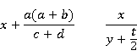

- When a mathematical expression is too long to be expressed in one line, subdivide the expression into smaller parts capable of fitting the line width (column width: 7 cm). Be sure to place the mathematical symbols =, +, −, ÷, and × at the beginning of each part of the expression.

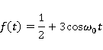
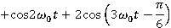
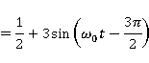
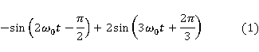

- When writing formulae, pay attention to the type and use of mathematical symbols (letters used in a formula should be written in italics unless specified).
- Use [ { ( ) } ] in this order of operations, with parentheses, braces, and brackets.
- As a general rule, use SI units. Write units in brackets [ ].

  - References
Textual citations should be indicated using serial superscript numbers (half-size Arabic numbers) with a closing parenthesis (for example, X¹⁾, Y^{2, 3)}, Z^{4–6)}), indicating the presence of references. All reference details should be listed at the end of the main body, in the order of the citations.

  - Footnotes
Do not use footnotes in the text. Treat comments and notes as references, not footnotes.

- Figures, Photographs, and Tables
  - Figures, photographs, and tables should be set off from the manuscript text.
  - Provide clear figures and photographs (par- ticularly photographs), as these are printed directly. Note that tables and explanatory texts are sometimes retyped for printing.
  - Figures and tables should be submitted as digital data.
  - Printed figures and tables must be either 70 mm or 140 mm wide.
  - Create figures and tables twice as large as printed size. In particular, pay attention to the size of letters and symbols in figures. Use thicker lines for better printing results.
  - Avoid large figures, photographs, and tables that must be folded when published.
  - Figure numbers should be referred to as Fig. 1, Fig. 2 (etc.), and table numbers as Table 1, Table 2 (etc.)
  - Figure or photograph captions (and explanatory text) should be written beneath the respective figure or photograph, and table captions (and explanatory text) above the table.
  - When figures are exceedingly small, or when instructions from the author are considered to be inappropriate, the Editorial Committee of the MASJ may request the author to revise the manuscript.
  - When creating figures and photographs, take into account the possibility that they may become black and white during on-demand printing or copying.

- Process from Submission to Publication
  - Papers and Letter Articles
- Writing
The author writes the cover page, English abstract, and main body, and produces the figures, photographs, and tables.
- Submission of manuscript
The author submits the manuscript for peer review as digital data in PDF format. The main body, figures, and tables created by word processing software should be combined into a single file in PDF format. Follow the instructions in Section 9 for submission. The manuscript is officially “received” on the day it is received by the Editorial Committee of the MASJ.
- Peer review
The Editorial Committee of the MASJ decides whether the manuscript should be published, while respecting the comments from the reviewers. The author may be requested to revise the manuscript or change the type of manuscript by the Editorial Committee. Refer to Appendix 1 for the peer review policy.
- Revision of manuscript
The author of the manuscript prepares a writ- ten response to the peer review comments, and revises the manuscript. If the manuscript is not resubmitted to the Society within six months after the manuscript is returned to the author, the acceptance of the manuscript is cancelled.
- Submission of revised manuscript
The author submits a written response to the peer review comments, along with a digital draft of the revised manuscript (in PDF format), as described in (2) above. Then, the manuscript is again peer reviewed.
- Preparation of the final manuscript
If the Editorial Committee decides to publish the manuscript, the English text (including abstract) in the manuscript is reviewed for error correction. The author is then required to incorporate the corrected English text so that the corrections can be reflected in the manual, and to prepare the final manuscript.
Requests regarding the following should be independently made to the Society: (1) the position of figures, photographs, and tables, and (2) other requests regarding printing (e.g., print size of figures and tables).
- Submission of final manuscript
Follow the instructions in Section 9 for the submission of the main body of the final manuscript, figures, and tables created by word processing software. In addition to the PDF file mentioned in (2) and (5) above, the author should submit the manuscript, figures, and tables in the format of the word processing software used to create them.
- Proofreading
As a general rule, the galley proof should be returned to the MASJ office within 24 hours (or by the designated date) after the author receives it. The author is requested to proof- read the galley proof, focusing particularly on the mathematical expressions, numbers, figures, tables, and typographical, clerical, or printing errors. The main body, figures, photographs, and tables should not be altered with respect to content or expression.
- Publication
Authors will be given a PDF of one issue of the Journal in which their work was published.

8.2 Other Manuscripts
- Writing
The author writes the cover page and main body, and produces the figures, photographs, and tables.
- Submission of manuscript
The author submits the main body, figures, and tables as digital data, in accordance with the instructions in Section 9.
- Proofreading
As a general rule, the galley proof should be returned to the MASJ office within 24 hours (or by the designated date) after the author receives it. The author is requested to proof- read the galley proof, focusing particularly on the mathematical expressions, numbers, figures, tables, and typographical, clerical or printing errors. The main body, figures, photographs, and tables should not be altered with respect to content or expression.
- Publication
Authors will be given a PDF of one issue of the Journal in which their work was published.

- Submission of Digital Data
9.1 Submission of Data
Manuscripts should be sent by e-mail, as attachments, to the MASJ office. If the attachment exceeds 8 MB, the file should be subdivided into several smaller documents, so that each can be sent by e-mail. In the accompanying e-mail, include the author’s name, the article’s title, the name of the OS used, and a list of attachments (with file name, contents, and name of software used).

9.2 Creation of Data
- Cover page
Download the cover page from the website of the Society (https://www.masj.jp), and complete.
- Abstract and main body
It is preferable for the abstract and main body of the manuscript to be created in Microsoft Word. If these are created in other software, convert them into a plain text format before submitting them to the MASJ office.
- Figures and photographs
- Line drawings (vector images), such as graphs, block diagrams and illustrations, created by Microsoft Word, Excel, Power Point, or Adobe Illustrator, may be submitted in their own file formats. Such digital data created by other software should be converted to WMF or EPS format before being submitted.
- Photographs and echograms of other types than those listed above should be converted into JPG or TIFF format before being submitted.
- When creating figures, take into account the possibility that they will be black and white during on-demand printing or copying.
- Tables
Tables created by Microsoft Word or Excel may be submitted in their own file format. Tables created by other software should be converted into a plain text format before being submitted.
- Before submission of a paper or letter manuscript for peer review, the files prepared in (2) to (4) above should be combined into a single PDF file.

10. Address for Submission
Manuscripts should be submitted to the following e-mail address.
submit[at]masj.jp (change [at] to @.)

Be sure to check the latest version of the "Author Guidelines for the Journal of the Marine Acoustics Society of Japan" on the website of the MASJ (https://www.masj.jp).

References
- “Author Guidelines for the Journal of the Marine Acoustic Society of Japan,” https://www.masj.jp/english/society/regulations/author-guidelines/?l=en_US (Last viewed 5 April 2024).
- D. E. Weston, "Wave-theory peaks in range averaged channels of uniform sound velocity," J. Acoust. Soc. Am., 68, 282-286 (1980).
- D. E. Weston, "Wave-theory peaks in range averaged channels of uniform sound velocity," J. Acoust. Soc. Am., 68(1), 282-286 (1980).
- L. L. Beranek, Acoustics (McGrawHill Book Co. Inc., New York, 1954), p. 180.
- J. J. Zwislcki, "Analysis of some auditory characteristics," in Handbook of Mathematical Psychology III, R. D. Luce, R. R. Bush and E. Galanter Eds. (John Wiley, New York, 1965), Chap. 15, p. 66.
- M. J. Buckingham and C. L. Epifanio, "Acoustic Daylight Imaging in the ocean: experimental results," Proc. the 3rd European Conf. on Underwater Acoustics, I, 341-347 (1996).
- R Core Team, "R: A language and environment for statistical computing," https://www.R-project.org/ (Last viewed 30 June 2022).
Table 1 Types of manuscript

Type of manuscript | Maximum number of pages | Content
Paper | 12 | Original articles that serve the development of scientific research and industry from the viewpoint of marine acoustics, such as the range of issues related to marine acoustics, as well as marine observation and investigation
Letter | 6 | Letters related to marine acoustics, including measured data, as well as improvement in measuring techniques and proposals
Other | Number of pages and content requested by the Editorial Committee
140mm

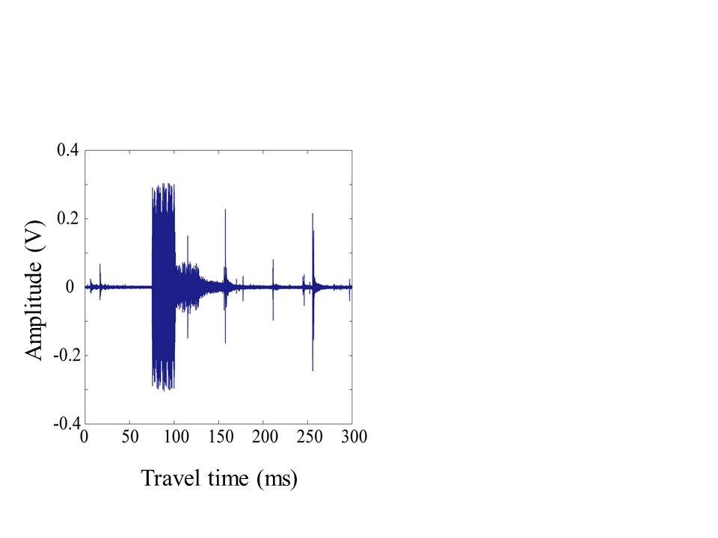

Fig. 1 Sample of received M-sequence signal.

70 mm

